LAB 1 REPORT
Student Name | YAHAYA DANJUMA ADDRA | Registration No. | C113/26/OCO/17001
Programme/Cohort | OCO/Cohort11 | Date | 04/09/2026
Instructor |  | Score | /100
Environment | Kali Linux / Ubuntu | Submission | E-Campus

TASK 1 REPORT
EVIDENCE:
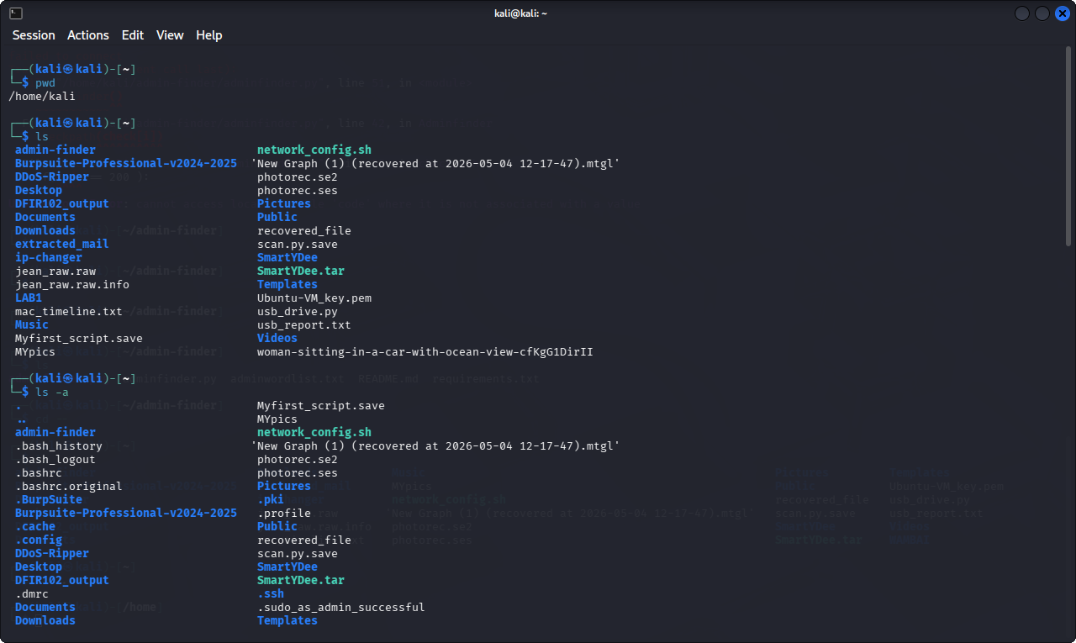
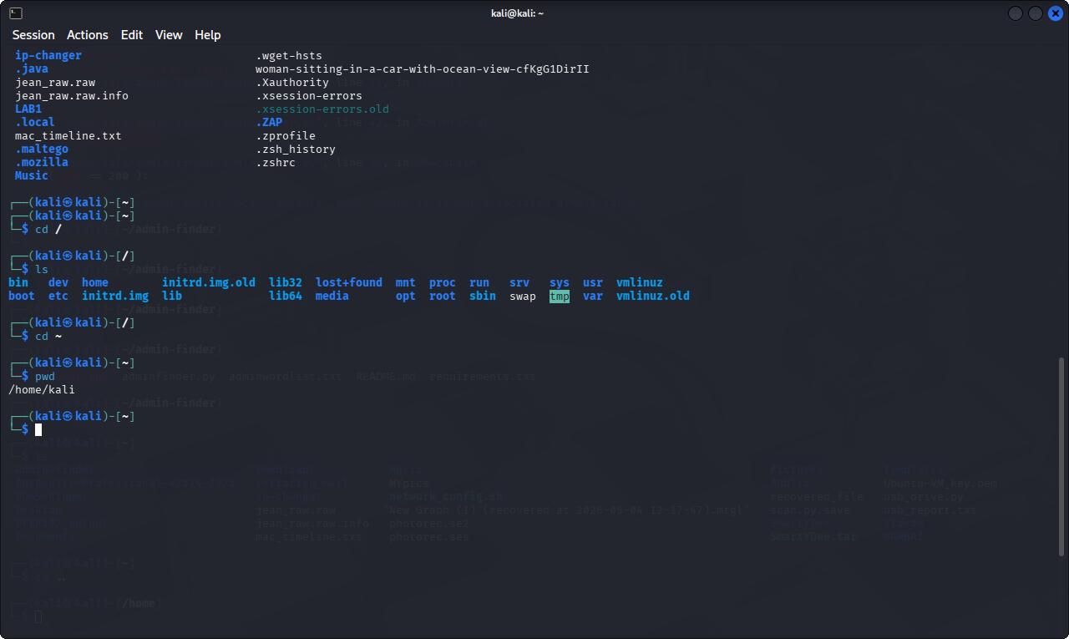
RESPONSE:
- Root (/) directory houses all other directories and files While Home (~) directory holds user’s personal folders and files.
- Root (/) directory is where the operating system seats on. For example, me am using Kali, it holds all the kali files and directory such as /var, /log, /home itself and whole lots while home (~) directory holds personal directories and files such as ICDFA_LABS, Task11.png, Task12.png etc.
- Root (/) directory has the administrative privileges i.e it has the super control over the operating system While Home (~) directory has the user privileges unless used a command called “sudo” to attain the administrative privileges
TASK 2 REPORT
Comparison between the inode number of the original file created and the renamed one:
Verdict: the first file is named oco1.txt with inode 1588531
The renamed file is named oco1.txt_renamed with the same inode number as the original file 1588531
EVIDENCE
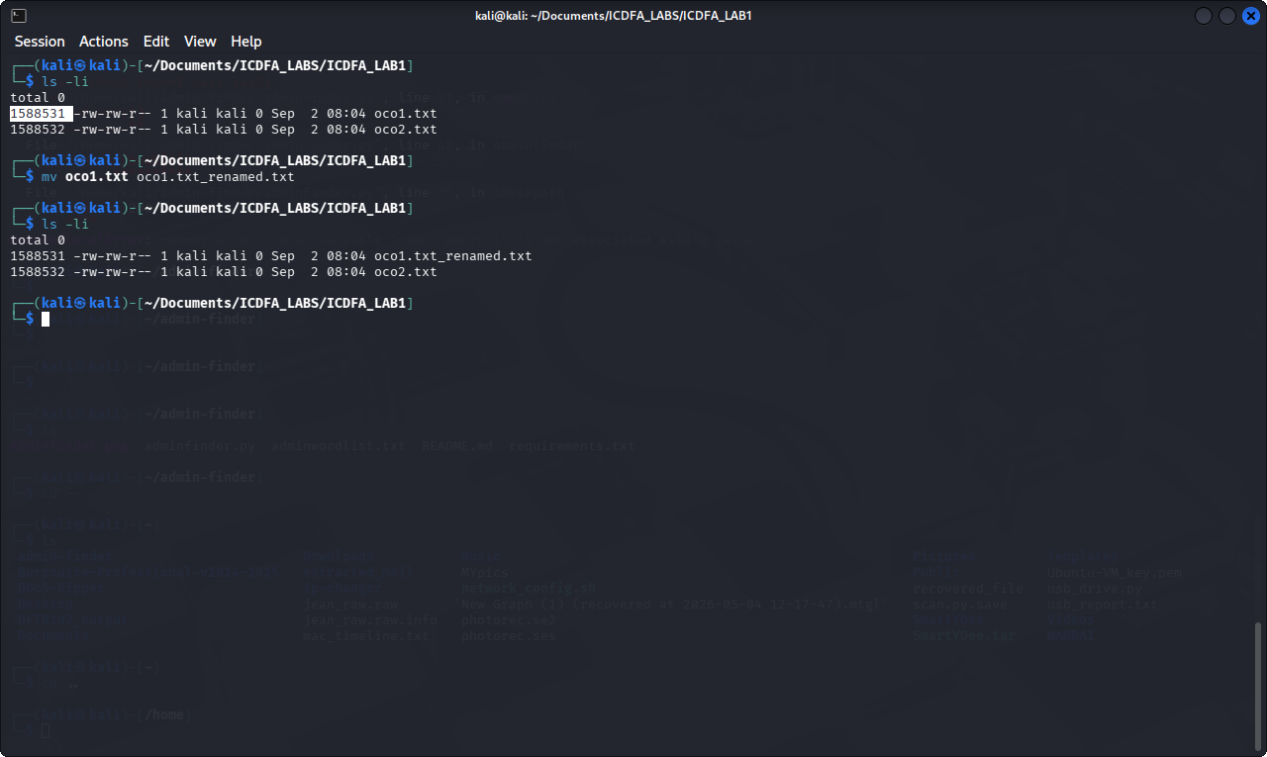

RESPONSE: No, the inode number remain unchanged even when the file name was changed

TASK 3 REPORT
EVIDENCE:
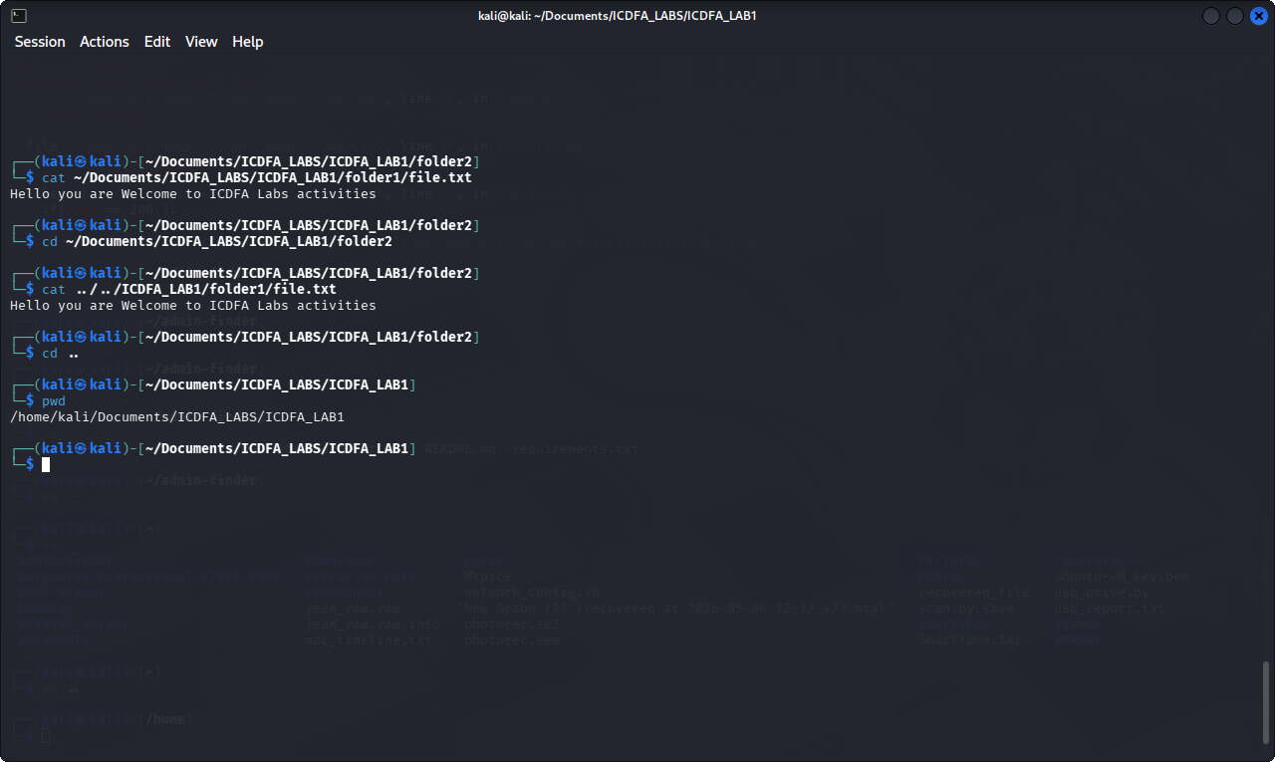

RESPONSE: in my onw understanding with absolute path, it tells the kali where the folder or file is irrespective of where you are while relative path depends on where you are currently working on.

TASK 4 REPORT
EVIDENCE:

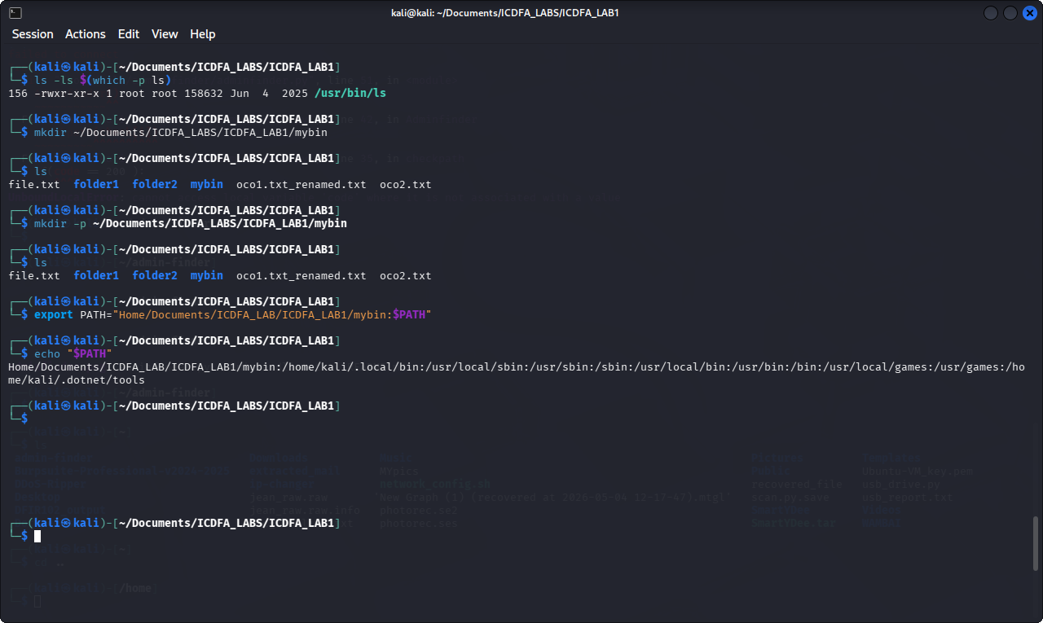
RESPONSE: If command is executed and couldn’t be found it would throw out an error that “command: command not found” and ask if you want to install it, if yes press “y” and enter your user password if no, ignore it. For example, if I write a command “hello” it will throw out an error because it is not an existing command in Linux or my Linux to be specific.
WHY ls COMMAND WOK EVERYWHERE?
Answer: Because ls command executable is stored in the PATH of every directory in the environment variable.

TASK 5 REPORT
EVIDENCE
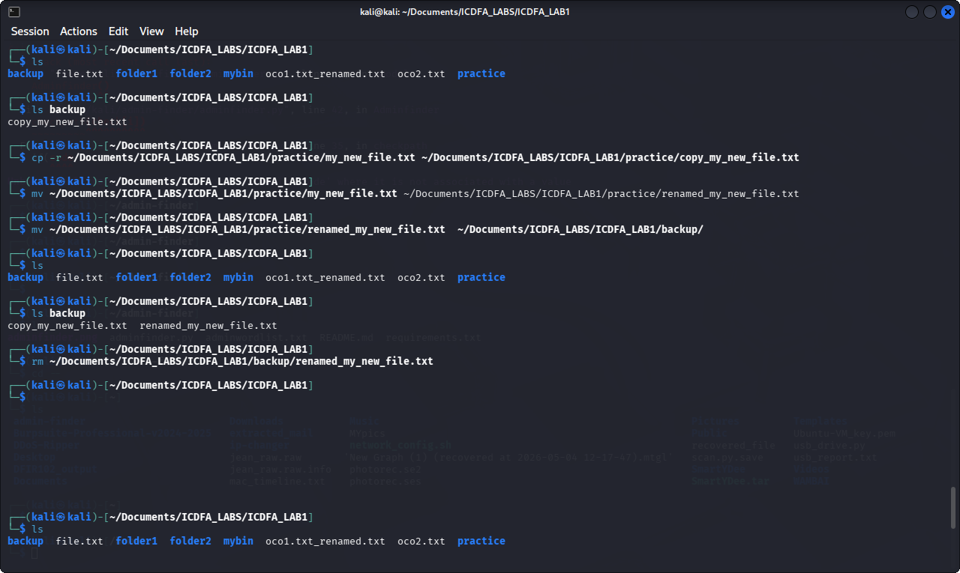
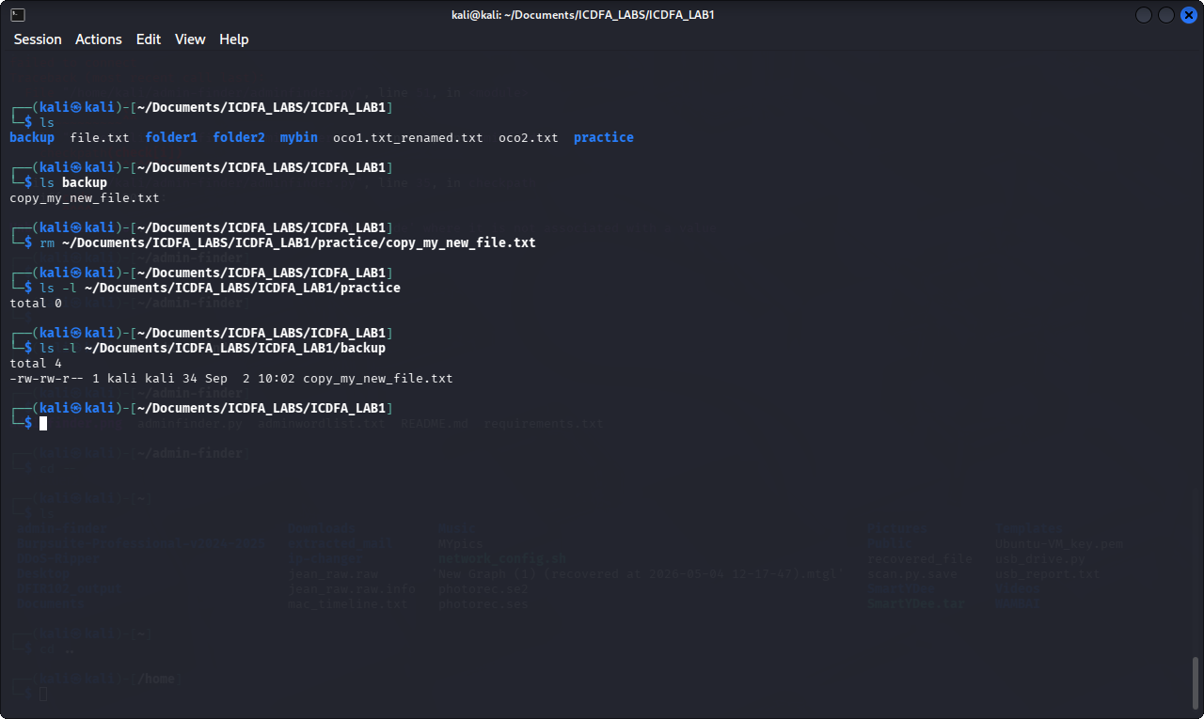

TASK 6 REPORT
EVIDENCE:
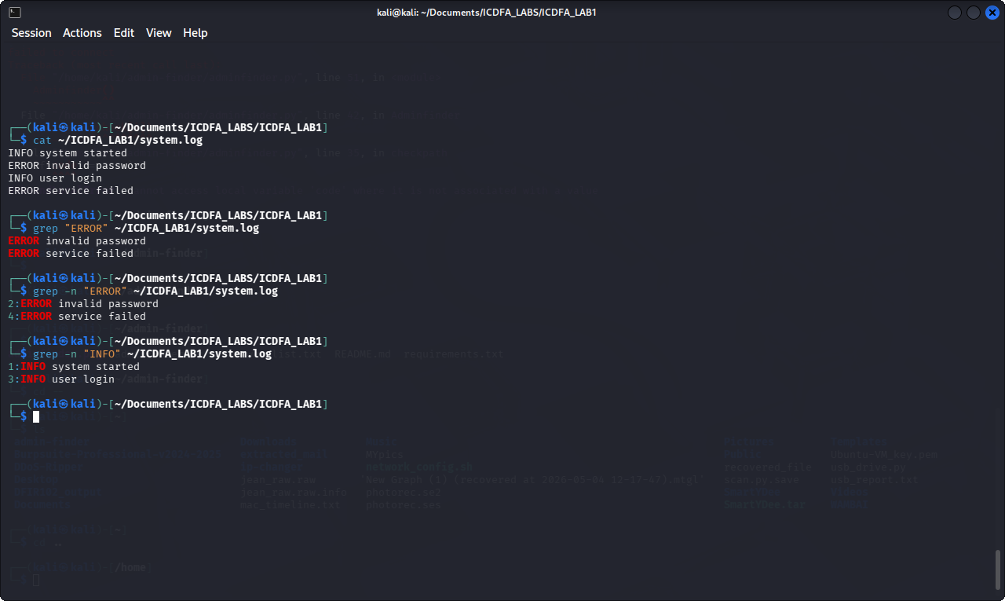

RESPONSE: The cyber security application I noticed in this log is, when the user is trying to log in with a wrong password the access was denied and popped up with a message “invalid password” the user further tried and it failed again. The security mechanism there is every user must enter their correct credentials before accessing whichever resources they should have. However, when authentication fails there won’t be room for authorization. And the logs are there for further forensics investigation.
TASK 7 REPORT
- What is an inode?
Answer: inode is a unique ID that stores metadata of a file, it metadata doesn’t change irrespective of the manipulation, such as change of file name, date, time etc.
- Why is pwd important before running file-manipulation commands?
Answer: pwd shows the user their current working directory, this help the user to understand which further step or command to run
- What is the difference between cp and mv?
Answer: cp copy the file and leave the original while mv moves or changes the file position completely without having its copy.
- Why should rm be used carefully?
Answer: because kali command doesn’t have undo and if the file is deleted it will take a long forensics process to bring it back

